INTERNATIONAL VOLUNTEER PROGRAM
HERE ARE OUR PROJECTS THAT RECEIVE VOLUNTEERS
We are currently working with the following centers located at:
State of Kerala:
- Nallasamarayan Ashram, phsyco-social rehabilitation center for women.
This center was founded in 1998 in Pulimayu, Kanjirapplly to provide care to women that suffer from any mental health, live in the streets, or they are victims of extreme poverty. Up until today this center had provided care to over 490 women. Out of these 490 women, around 360 women are rehabilitated and they gained stability which allowed them to come back to their families or other centers. Currently, the center takes care of 31 women.

Center managed by the entity We Care Center http://wecarecentre.org/
More information about this center:
http://wecarecentre.org/2018/01/16/nalla-samarayan-asram-kanjirappally/
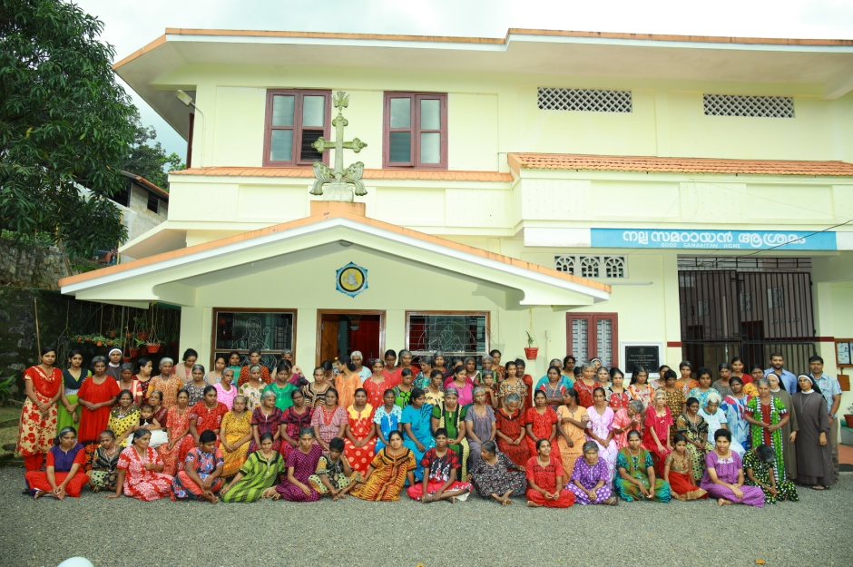

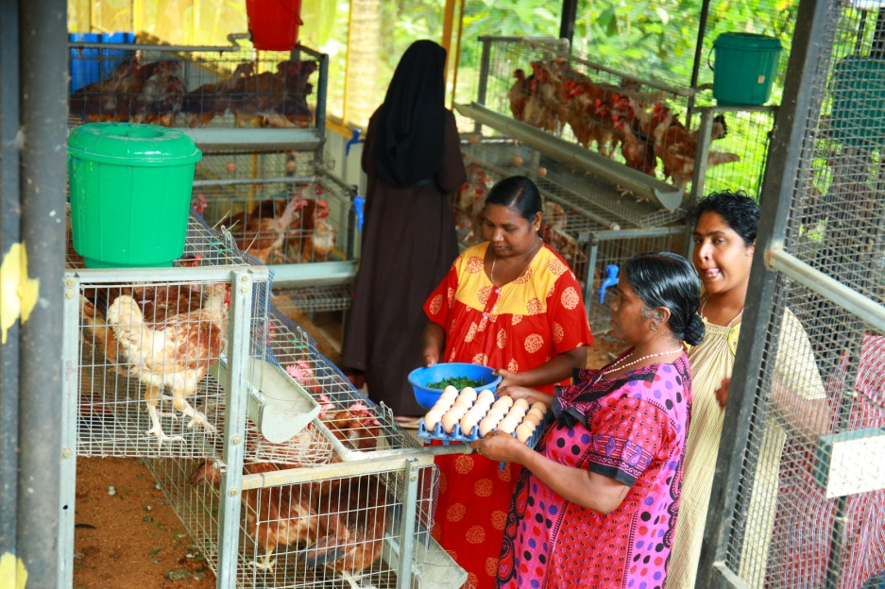

- Bethlahem Ashram
The center Bethlehem Ashram was founded in 1998 with the purpose to provide a home and protection to single women and abandoned children. These families have a very poor economic and social situation. Fort that reason, the center provides them with food, a place to live, clothes, education, etc. The kids also have the opportunity to learn music, dance, and perform other extra-curricular activities Once a year, the kids travel with us to different touristic places. The center’s activities are supervised by religious women that belong to the Congregation “Sagrado Corazon”.

The center is managed by the entity We Care Center http://wecarecentre.org/
More information about the center:
http://wecarecentre.org/2018/01/16/bethlehem-ashram-vandanpathal/

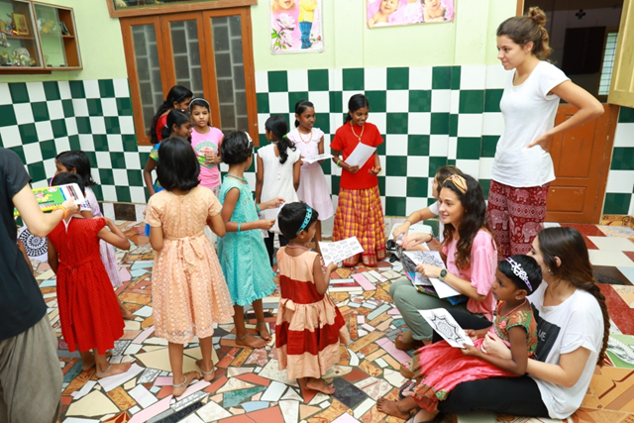

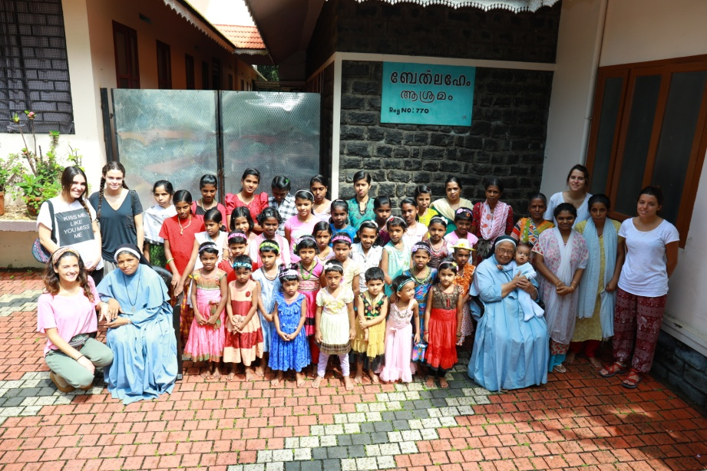

State of Tamil Nadu:
- House of St. Joseph and Mother Theresa
The house of St. Joseph is for boys and the house of Mother Theresa is for girls. Both houses were established with the objective to take care of the most basic needs of orphan boys and girls that needed the care of a parent. Or, also some kids came from poor families. The house of St. Joseph and Mother Theresa provide the kids with protection, care, and love while covering the kids’ most basic needs such as food or clothes, but above all, access to education. The maintenance of these houses allow the kids not to work, which is great because kids should not work due to their poor economic and social condition. Currently, these centers welcome over 100 minors.

Center managed by the entity Tiruchirappalli Multipurpose Social Service Society (TMSSS): http://www.tmsss.org/
More information about this center: http://www.tmsss.org/programme/education-care-and-support-for-poor-boys-and-girls-2/
